PHASE – 3

(CAPSTONE PROJECT)

SQL OPERATIONS

3.1

Insert records from 42_District_wise_crimes_committed_against_women_2001_2012.csv into a table

Query:

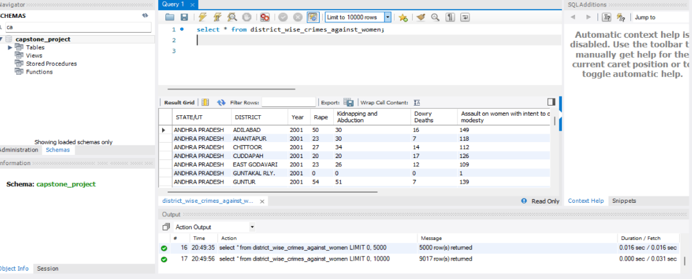

3.2

Write SQL query to find the highest number of rapes & Kidnappings that happened in which state, District, and year

Query:

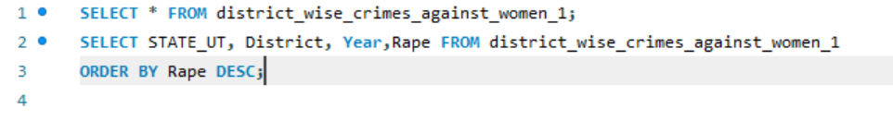



Ex output:

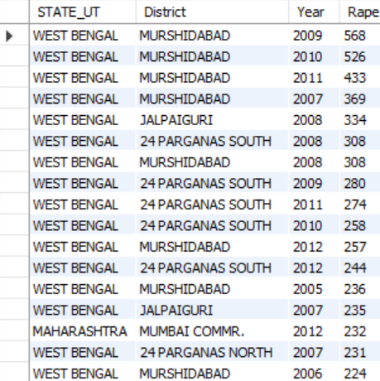 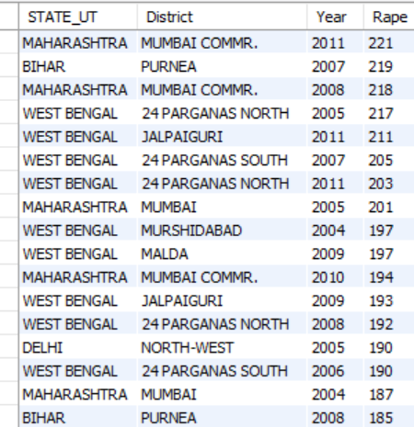

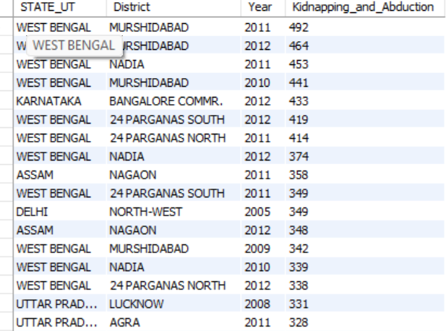 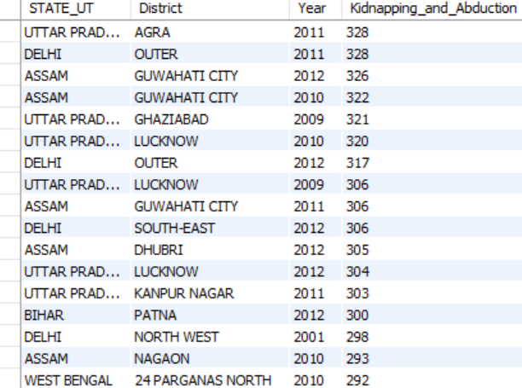

3.3

Write SQL query to find All the lowest number of rapes & Kidnappings that happened in which state, District, and year.

Query:

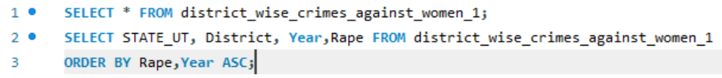



Ex Output:

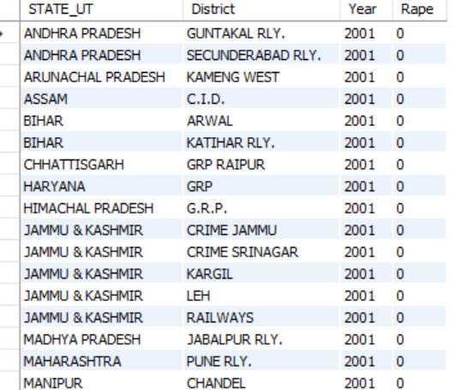 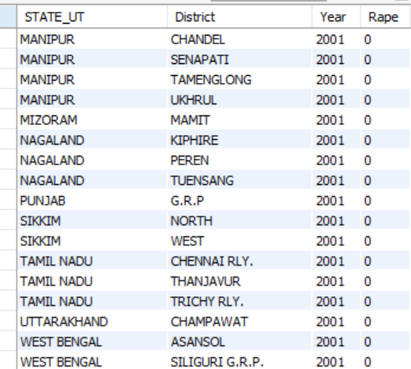

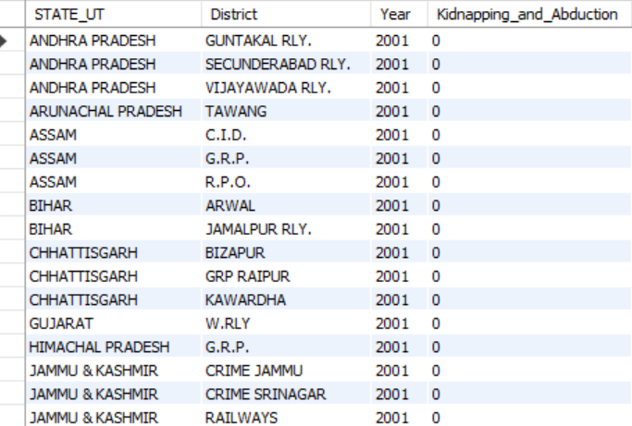 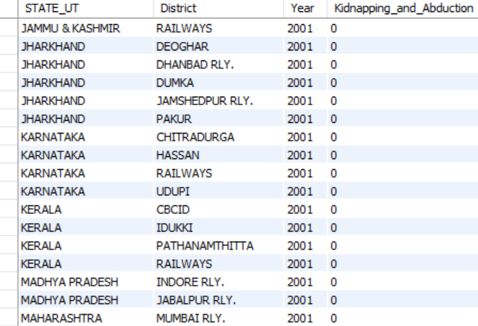

3.4

Insert records from 02_District_wise_crimes_committed_against_ST_2001_2012.csv into a new table.

Query:



Ex output:

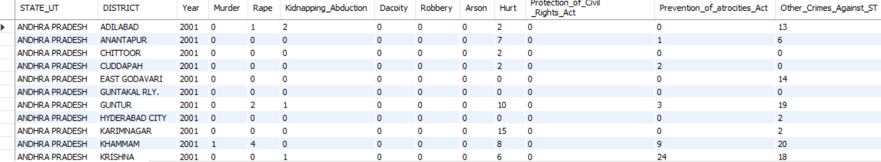

3.5

Write SQL query to find the highest number of dacoity/robbery in which district.

Query:

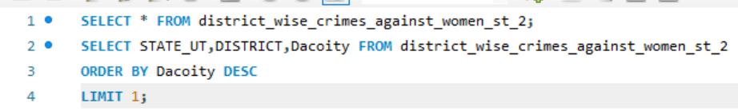

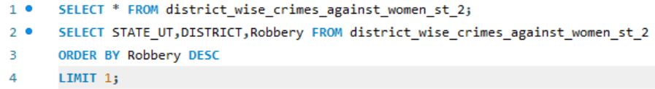

Ex Output:

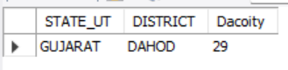

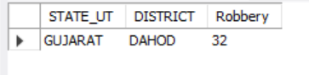

3.6

Write SQL query to find in which districts(All) the lowest number of murders happened.

Query:

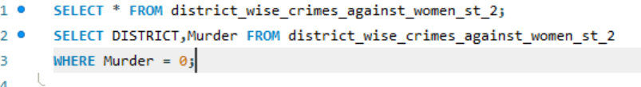

Ex Output:

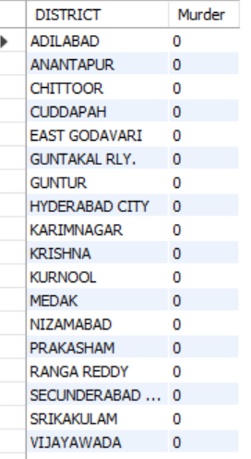 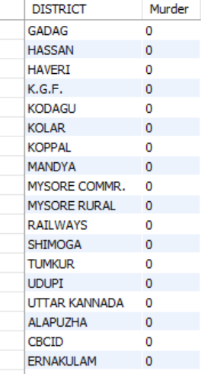

3.7

Write SQL query to find the number of murders in ascending order in district and yearwise.

Query:



Ex Output:

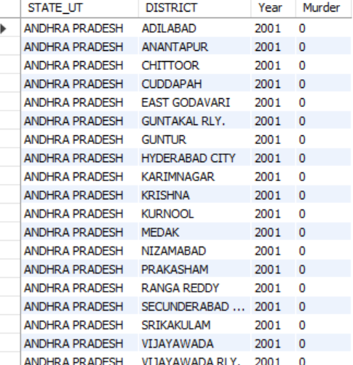

3.8.1

Insert records of STATE/UT, DISTRICT, YEAR, MURDER, ATTEMPT TO MURDER, and RAPE columns only from 01_District_wise_crimes_committed_IPC_2001_2012.csv into a new table.

Query:



Ex Output:

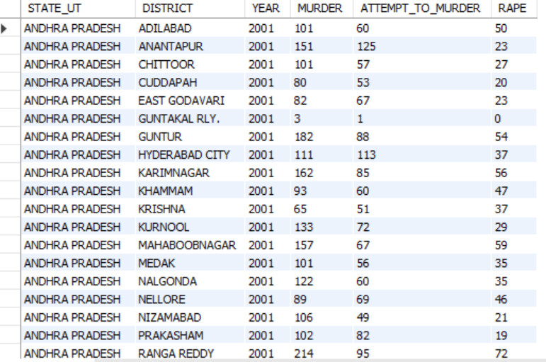

3.8.2

Write SQL query to find which District in each state/ut has the highest number of murders yearwise. Your output should show STATE/UT, YEAR, DISTRICT, and MURDERS.

Query:

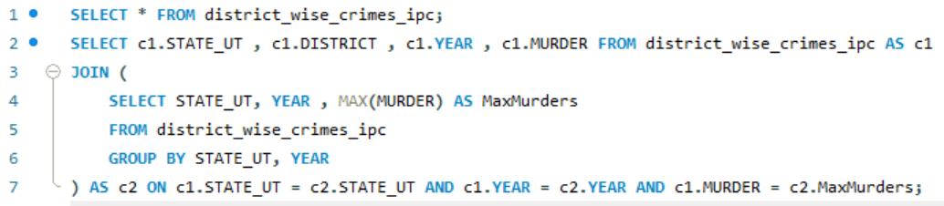

Ex Output:

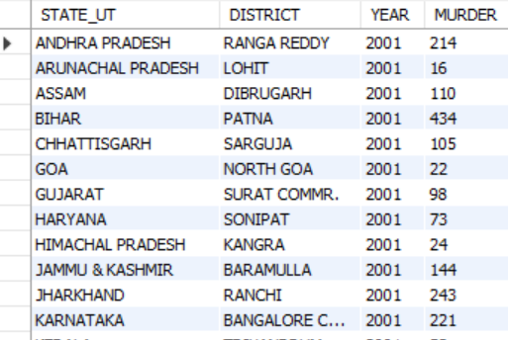 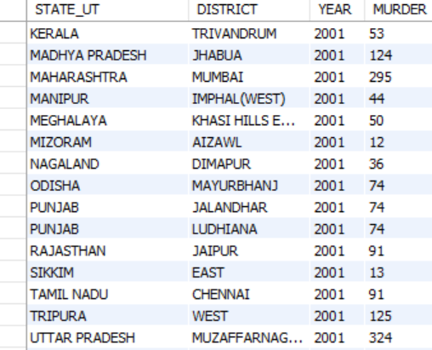

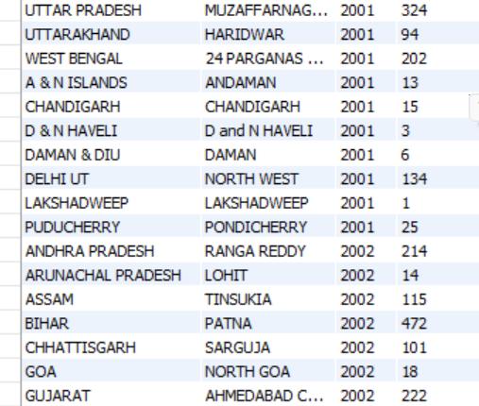

3.8.3 and 3.8.4 are executed in a jupyter notebook.